Library Management System

**Create a database named library and following TABLES in the database:**   
  
1. Branch   
2. Employee   
3. Books  
4. Customer  
5. Issue Status  
6. Return Status

**\*Attributes for the tables:**   
  
1. Branch  
  
• Branch_ no

* Set as PRIMARY KEY

• Manager_ Id    
• Branch_ address    
• Contact_ no

2. Employee    
  
• Emp_ Id – Set as PRIMARY KEY    
• Emp_ name    
• Position    
• Salary  
• Branch_ no

* Set as FOREIGN KEY and it refer Branch_ no in Branch table

3. Books    
  
• ISBN

* Set as PRIMARY KEY    
  • Book_ title    
  • Category    
  • Rental_ Price    
  • Status [Give yes if book available and no if book not available]    
  • Author    
  • Publisher

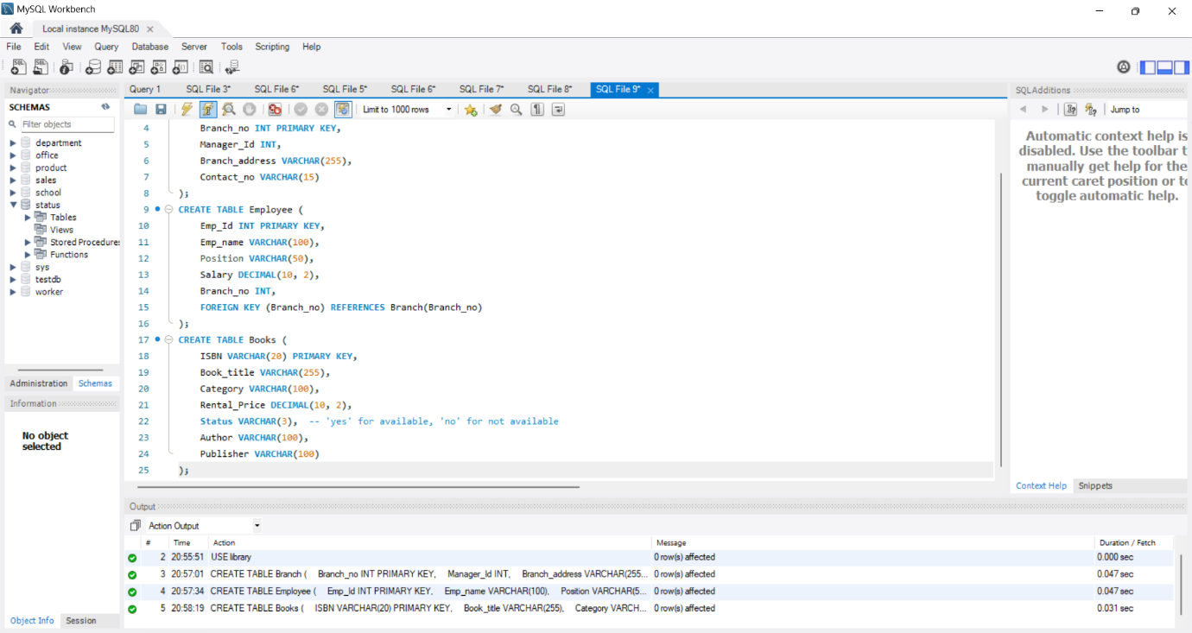

4. Customer    
  
• Customer_ Id

* Set as PRIMARY KEY    
  • Customer_ name    
  • Customer_ address    
  • Reg_ date

5. Issue Status    
  
• Issue_ Id

* Set as PRIMARY KEY    
  • Issued_ cust – Set as FOREIGN KEY and it refer customer_ id in CUSTOMER table Issued_ book_ name   
  • Issue_ date   
  • Isbn _ book – Set as FOREIGN KEY and it should refer isbn in BOOKS table

6. Return Status    
  
• Return_ Id

* Set as PRIMARY KEY    
  • Return_ cust    
  • Return_ book_ name    
  • Return_ date    
  • Isbn_book2
* Set as FOREIGN KEY and it should refer isbn in BOOKS table

**Display all the tables and write the queries for the following:**

1. *Retrieve the book title, category, and rental price of all available books.*

*2.List the employee names and their respective salaries in descending order of salary*

*3.Retrieve the book titles and the corresponding customers who have issued those books.*

*4.Display the total count of books in each category.*

*5.Retrieve the employee names and their positions for the employees whose salaries are above Rs.50,000*

*6.List the customer names who registered before 2022-01-01 and have not issued any books yet.*

*7.Display the branch numbers and the total count of employees in each branch*

*8.Display the names of customers who have issued books in the month of June 2023*

*9.Retrieve book_ title from book table containing history.*

*10.Retrieve the branch numbers along with the count of employees for branches having more than 5 employees*

*11.Retrieve the names of employees who manage branches and their respective branch addresses.*

*12.Display the names of customers who have issued books with a rental price higher than Rs. 25.*

